Appendix 'N'

1

Wellbeing, Prevention and Early Help Service for Children, Young People and Families in Lancashire

Service offer and specification

Section 1 Contents

Sections
Appendices

- Contents Page 2

- Service context Page 3

- Service specification Page 4

- Service description Page 5

4.1 Service purpose

  - Service outcomes

  - Target groups

  - Service delivery footprint

  - Service point of access

  - Service delivery methods

  - Anticipated demand & resource allocation model for casework
  - Governance arrangements
- WPEHS outcomes framework Page 9

- WPEHS key priority target groups Page 10

- Demand and resource allocation model for

casework Page 11

- Service delivery model for group based

delivery through Neighbourhood Centres Page 14

- WPEHS budget including staffing

establishment Page 20

- The Lancashire Continuum of Need Page 22

Section 2 Service context

The case for effective Wellbeing, Prevention and Early Help is well documented and understood and has been robustly made in a number of key national reports. This is that Early Help for children, young people and their families does more to reduce the prevalence of abuse and neglect than reactive (costly) specialist statutory services. That it focuses on impacting the wider determinants for health, including economic, social and environmental improvement in both local and national context.
Prevention and Early Help is a way of working with children, young
people and families, offering help and support at the earliest opportunity. This prevents problems from getting worse and in turn, prevents children, young people and families requiring more intensive/specialist help. By responding to people's needs earlier we believe it is more likely that demand on emergency and specialist services, which are expensive, will reduce. Early Help can involve a number of agencies to help a family get the support they need and operates by providing a 'lead professional' who can coordinate the support needed and be the key contact for a family.

By working with families Early Help aims to build their resilience, increasing their ability to manage challenging circumstances before they become a problem. Early Help offers children, young people and families more than just a solution to a specific problem; it offers them help to develop the skills needed to deal with a similar problem if it arises in future. Early Help is offered within a family context but can also focus on individual family members specific needs.
The Wellbeing, Prevention and Early Help Service (WPEHS) brings together a range of former services that work with children, young people and families, including Children's Centres, Young People's Service, Prevention and Early Help and Lancashire's response to the national Troubled Families Unit programme.

By doing this, the service is able to offer a wide range of support across the 0 - 19yrs+ age range (25 years for SEND) with a whole family approach, and ensure that the needs of children, young people and families who are vulnerable to poor outcomes are identified early and that those needs are met by agencies working together effectively and in ways that are shaped by the views and experiences of the children, young people and families themselves.

Effective early help requires a whole family approach and can encompass a multi-agency response for those with more complex needs. It contributes to meeting key targets focussed on the wider determinants for health, including economic, social and environmental improvement in both local and national context, building resilience within individuals, families and communities and increasing their capacity to manage challenging circumstances before poor outcomes develop. This provides more than a solution to a specific problem; it builds skills to deal with a similar problem if it arises in future. Preventative work focus on reducing risk and promoting protective factors in the child, young person or family thereby promoting resilience and improving wellbeing.

Section 3 Service specification

WPEHS delivers its services within communities and will operate from a number of neighbourhood centres across the County. The service operates a flexible programme, largely targeted in response to need, but also including some universal drop-in services and groups.

Each will work to a core (group based) delivery specification (around seven delivery sessions per week) which may be split across two specific neighbourhood centres in order to better respond to the different access needs of children/families and young people.

One identified neighbourhood centre in each 'district' area provides an enhanced group based delivery specification (twelve delivery
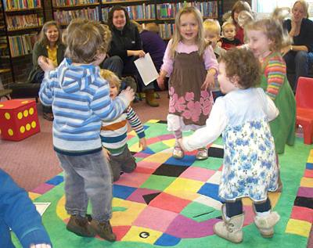sessions per week), though this may also be split across two centres for the same access reasons

Within this number of delivery sessions the service is accessible when most needed, Monday- Friday (inclusive), throughout the daytime and provides some evening sessions, largely focussed on young people. The service also

has some weekend opening hours as needed. Overall this will enable 452 delivery sessions per week across Lancashire.

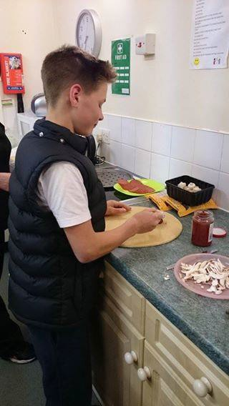The services are prioritised to targeted groups and those who are most vulnerable.

It is delivered through one to one key worker support and group based activities from neighbourhood centres or through one to one outreach and detached support.

By using outreach and detached methods we ensure a wide reach of our services across communities and where appropriate, this can be delivered within families' homes, or from other appropriate community settings.

The services include 'virtual'
support, accessed for example via telephone, internet or mobile phone as part of the 'Talkzone' suite of services.

Further details and information about the service delivery model are available in the appendices to this document.

Section 4 Service description

The following information sets out a description of Wellbeing, Prevention and Early Help Service in the context of its delivery model;

Service Purpose

Lancashire's Wellbeing, Prevention and Early Help service offers support to children, young people and families age 0-19+yrs (0 - 25yrs for SEND) and their families. The service identifies as early as possible when a child, young person or family needs support, helping them to access services to meet their needs, working with them to ensure the support offered is right for them, offered in the right place, at the right time.

Target groups

The main focus of the service will be on providing an enhanced level of support to individual children, young people or families with higher levels of need. The service will uphold its statutory universal responsibilities in delivering a core 'children centre' offer for 0-5yrs, including universal information, advice and guidance. This will operate alongside key partners including Midwifery, Health Visiting and School Nursing.

WPEHS will prioritise resources towards identified key priority target groups or individuals at risk.
The targeted early help offer will be delivered to those assessed using Lancashire's Common Assessment Framework (CAF) as having more complex or intensive needs aligned to Lancashire's

Revised Continuum of Need (CoN) at Levels 1, 2 and additional support where required of the service (by social care) to level 3.
NB: The Lancashire CoN was revised from July 2016 and level
indicators changed. Formerly early help sat at Level 3 on the CoN and now sits at Level 2, whilst statutory responses sat at Level 4 and now sit at Level 3.
See Appendix C for details of these priority target groups and Appendix M for details of the revised Lancashire Continuum of Need (CoN).

Service outcomes

The key outcomes the service aims to achieve include:
    - Children and young people are safe and protected from harm
    - Children, young people and their families are resilient, aspirational and have the knowledge, capability and
capacity to deal with wider factors which affect their health and wellbeing, life chances and economic wellbeing
    - Children, young people and families are helped to live healthy lifestyles, engage in positive social activities and
make healthy choices
    - Children, young people and families health is protected
from major incidents and other threats, whilst reducing health inequalities
    - Those in more disadvantaged communities, the number of children, young people and families living with preventable
ill health and dying prematurely is reduced

See Appendix B for details of the WPEHS Outcomes Framework

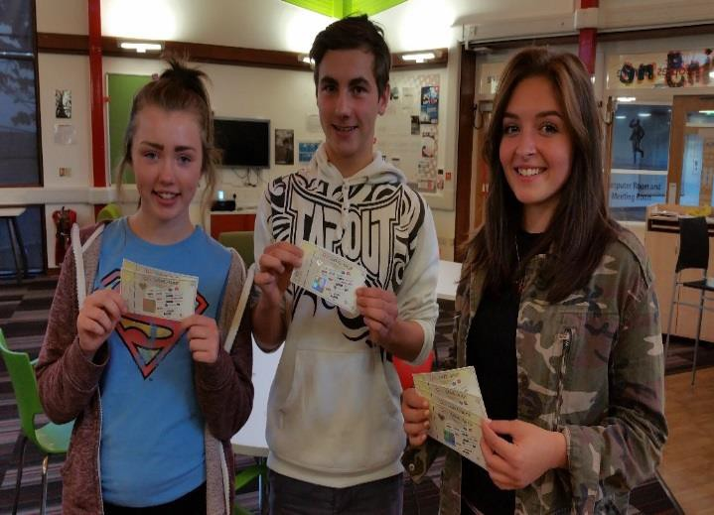

Service delivery footprint.

For organisation and management purposes, front facing service delivery will be structured around five cluster areas (localities) which will form the service delivery footprints for WPEHS. These are;

- Lancaster, Fylde and Wyre

- Preston

- Chorley, South Ribble, and West Lancashire

- Hyndburn, Ribble Valley and Rossendale

- Burnley and Pendle
These service delivery footprints are configured appropriately with other current key operating frameworks such as Health economies/CCGs, Travel to learn areas and arrangements around Children's Partnership/ Health and Wellbeing Boards. This provides some level of future-proofing around planning alignment as well as operating efficiencies

Service point of access

The Wellbeing, Prevention and Early Help service will be based in neighbourhood centres and will operate a flexible programme of service delivery, drop-in services and groups, to meet the identified needs of children, young people and families in the local neighbourhood.

Section 3 gives further detail of the delivery specification for the services in neighbourhood centres.

The following factors, amongst others, have been considered when determining the combination of 'neighbourhood centres' most suited to hosting WPEHS delivery. This ensures sufficiency of both 'access' and 'reach' for delivery model for WPEHS;

- Points of access within principle communities with good access and sufficient neutrality to ensure different communities will use the facilities.
- Spread of access points which ensure the ability to establish links to centres within defined reach areas (Department for Education defined/children centres)
- Distance gaps between provision – it is good practice to aim for
access within 30 minutes reasonable travel distance (walking)

- Buildings which are sufficiently flexible to respond to the diverse needs of 0-19+ and families, including discrete one to one spaces, flexible group spaces, adequate storage and access facilities etc.

Service delivery methods

The service will be offered in the main to groups and individuals whose needs are our priority and use four principle methods for service delivery;

- One to one key worker support

- Group based programmes operating from neighbourhood centres
- One to one and group based outreach and detached support.

- Virtual and digital support, which is accessed for example via telephone, internet, mobile phone and social media.

Using outreach and detached delivery is critical and means that there is a wide reach of our services across communities and where appropriate, this can be delivered within families' homes, or from other appropriate environments.

See Appendix E for details of the proposed service delivery model for group based delivery through Neighbourhood Centres.

Anticipated demand and resource allocation model for casework.

Based on an assessment of the pattern of historic service demands, it is anticipated that WPEHS requires capacity to safely respond to approximately 10,000 cases each year, comprising a mixture of children, families and young people.

This incorporates Lancashire's response to the national Troubled Families Programme.

Further to this, WPEHS will allocate resources to enable neighbourhood centre based and outreach group activity which can cost effectively respond to defined needs and include an appropriate response to universal statutory responsibilities.

Resources are deployed using a caseload allocation model which balances the distribution of personnel in order to meet the demand.

See Appendix D for further details of proposed resource model for case allocation.
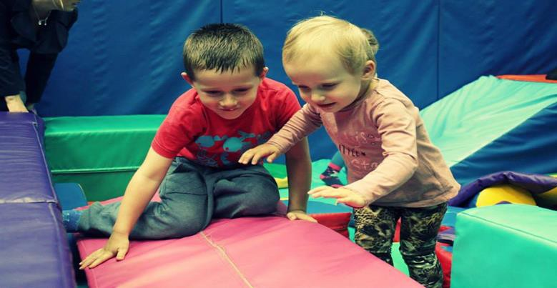

Governance arrangements

WPEHS reports on its outcomes and performance through a multi- agency governance structure (Children's Partnership Board) and where appropriate the Health and Wellbeing Board, as well as reporting to Lancashire Safeguarding Children's Board. This aligns with service delivery footprints at a County and local level. The governance role responds to the national Troubled Families Unit programme in Lancashire.
The children centre 'advisory board' function, in line with statutory expectations, is aligned with appropriate clustering arrangements at a local level (districts) to ensure local accountability and the inclusion

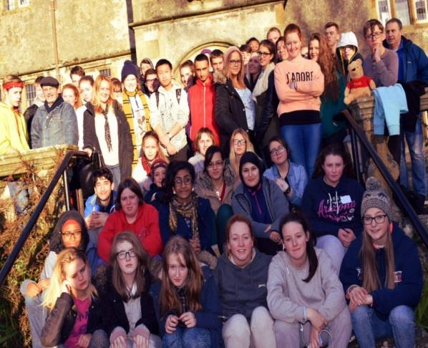
of local stakeholders including parents. This meets the requirements of the statutory Ofsted Inspection framework.

The voice and influence of children, young people and parents is embedded within governance arrangements and strong links are maintained with appropriate networks and forums which enable this dialogue and influence on WPEHS delivery arrangements. This includes e.g. Lancashire Youth Council, Parent Forums etc.

Governance structures will work to defined terms of reference and core suggested membership which will outline their role as providing 'challenge/scrutiny and support' to locally delivered WPEHS. They will not manage delivery of services nor any associated budgetary resources. Early Help and the designated Children Centre function within WPEHS will continue to be subject to external Ofsted inspection.

Appendix A WPEHS outcomes framework
WPEHS focusses on achieving positive impact for children, young people and their families in five key areas. These 'outcomes' are strategica lly aligned with Lancashire's expectations in the Children and Young People's Plan and to the Marmot principles (Fair Society, Healthy Lives, and Marmot 2010) and incorporate our responsibilities in responding to the requirement of the national Troubled Families Programme.

Outcome 1 | Outcome 2 | Outcome 3 | Outcome 4 | Outcome 5
Children and young  people are safe and protected from harm. (Children and Young People's Plan Objective 1) | Children, young people  and families are resilient, aspirational and have the knowledge, capability and capacity to deal with wider factors which affect their health and wellbeing, life chances and economic wellbeing (Children & Young People's Plan Objective 2, 3) | Children, young people  and their families are helped to live healthy lifestyles, engage in positive social activities and make healthy choices  (Children & Young People's Plan  Objectives 2, 4, 5) | Children, young people  and families health is protected from major incidents and other threats whilst reducing health inequalities (Children & Young People's Plan Objective 1, 4) | Targeting those in more  disadvantaged communities, the number of children, young people and families living with preventable ill health and dying prematurely is reduced (Children & Young People's Plan Objective 1, 3, 4)
Marmot Objective  A, B, C, D, E, F | Marmot Objective  B, C, D | Marmot Objective  A, B, C | Marmot Objective  D, F | Marmot Objective  A, C, D, E
TFU Criteria  1, 3, 5 | TFU Criteria  1, 2, 3, 4, 5, 6 | TFU Criteria  1, 2, 4, 5, 6 | TFU Criteria  1, 3, 5, 6 | TFU Criteria  4, 5, 6
Marmot Objectives
A. Best start in life for children. B. Maximise your capabilities and have control over your life. C. Fair employment and good work for all. D. Healthy standard living. E. Healthy and sustainable places and communities. F. Ill health prevention
Troubled Families Unit Criteria
- Parents or children involved in crime or anti-social behaviour
- Children who have not been attending school regularly
- Children who need help: children of all ages, who need help, are identified as in need or are subject to a child protection plan
- Adults out of work or at risk of financial exclusion or young people at risk of worklessness
- Families affected by domestic violence and abuse
- Parents or children with a range of health problems

Appendix B WPEHS key priority target groups

When considering targeting services, Wellbeing, Prevention and Early Help Service will prioritise the following groups/ individual children, young people or families;

With Special Educational Needs and/or Disabilities or with behaviour difficulties
- Experiencing Neglect
- Workless or at risk of financial exclusion
- With a range of health problems
- Affected by domestic abuse
- Affected by emotional and mental health issues
- Young Parents/ new parents
- Parents who are unlikely to take advantage of universal early childhood services
- Young Carers
- Homeless
- Asylum seekers and refugees
- At risk of and/or having experienced child sexual exploitation
- Who are transient including asylum seekers, economic migrants and traveller communities
- Involved in crime or anti-social behaviour
- Not attending school regularly and at risk of exclusion
- Engaging in / affected by risk taking behaviours
- With protected characteristics as defined by the Equality Act 2010

(WPEHS will support Children's Social Care cases (including Children in Need (CiN) and those stepping down from social care), where in the best interest of the child/young person, and as part of plans for children and young people looked after by the local authority and those subject to a child protection plan)

Appendix C Demand and resource allocation model for casework

Based on historic knowledge of service demand we have established baselines which indicate predicted levels of demand within an annual cycle. Based on the levels of response required, this then indicates the required resource investment to meet the level of predicted. The following numbers are a snapshot of historical demand based on the former Lancashire CoN levels (pre-July 2016.

Overarching Demand  Embedded within are minimum 1420 (plus c.25% for outcome |  | security) TFU fam | Allocated Caseload Demand  ily cases comprising c.4,686 individuals (average per annum) |  |  | Footfall | Cases Continuum of Need (CoN) Level 2  (NB: former Lancashire CoN
level – pre July 2016)
Open CAFs | Early Support Requests for Support | Children Centres Family Support  (Level 3,4a-c CoN)  (NB: based on former Lancashire CoN level – pre July 2016) |  | Targeted Youth Support  (Level 3,4a-c CoN)  (NB: based on former Lancashire CoN level – pre July 2016) | Children | Young People | Children | Young People
4597 | 4147 | 1,182 |  | 3,463 | 71,102 | 16,802 | 4,387 | 885
Multi-agency identified needs where WPEHS is  not the only responding agency (Lead Professional) |  | Direct casework demand within WPEHS  (Includes proportion of cases which originate through CAF/Early Support-Requests for Support) |  |  | Centre Based and outreach group  activity responding cost effectively to common themes in response to defined needs |  | Universal responses and  family support where there is identified unmet needs

In the future, WPEHS needs to be in a position to adequately respond to up to 10,000 cases per year as this will build in sufficient flexibility to respond to increase and peaks in demand and some cases at the margin of CoN 1 which are considered important to limit escalation. From this indication of demand levels we have calculated our caseload capacity and from this an indication of the minimum levels of staffing which will be needed to provide a safe and sufficient response. The following profile of the 10,000 cases in WPEHS is used to calculate the workforce response that will be required. In general terms, based on this demand, we calculate the profile to breakdown as follows (based on the revised Lancashire CoN levels;

 | General % Profile | Case numbers
CoN cases at level 3. To support de-escalation and transition pathways (where the  service is identified to address a specific identified need as part of a statutory plan). | 5% | 500
CoN cases at level 2 - Type A (requiring higher frequency of intervention and  programmes which require weekly contact) | 40% | 4,000
CoN cases at level 2 - Type B (requiring less frequency of intervention support) | 50% | 5,000
CoN cases at level 2 de-escalating to level 1 (requiring less frequency of intervention  support) | 5% | 500

Overview of Caseload Allocation Formula WPEHS
Allocation of caseload at levels 2 and above on the Continuum of Need is based on the above profile and governed by the following principles;

 | Frequency of  intervention | Frontline Delivery Visit/Group  Duration | Support Schedule | TOTAL delivery slots | Cycles per year
CoN cases at Level 3 | Weekly  (incorporating review | Up to 2.5hrs  (to include recording and initial | 15 weeks  (extensions by review) | 15 per case cycle | 3
 | meetings (multi-agency) | actions/ follow up)
CoN cases at Level 2 Type A | Weekly | Up to 2.5hrs to include recording  and initial actions/follow up | 12 weeks  (extensions by review) | 12 per case cycle | 3.8
CoN cases at Level 2 Type B  & Level 2 de-escalating to | Fortnightly | Up to 2.5hrs to include recording  and initial actions/ follow up | 12 weeks  (extensions by review) | 6 per case cycle | 3.8
universal support

WPEHS staff who hold caseloads will carry an average mixed caseload of 18 cases, with the following general proportionality
(drawn from the profile above); Caseload calculations are based on each FTE staff member having a 'frontline delivery visit/group' potential of;

Caseload Allocation – 18 cases

Level 2 Type B

Level 2 Type A
Level 3

0 5 10 15

No. of Cases
- 46 weeks per year
- Up to 11 'visits' per week (mitigated by demands of complex cases/ partnership contact/ follow up and multi- agency processes
Maximum potential of 506 delivery slots per annum – per FTE.

NB: A case in WPEHS is not a count of individuals linked to a caseworker. A case may be a family with multiple individuals – therefore the total number of 'held' individuals may be significantly higher than 18 individuals.

Mixed caseloads of 18 cases – cycling at the above duration and frequency would necessitate per FTE;

Key Worker Deployed Hours
 | Delivery Slots | Number of cases (families) per year
1 cases @ Level 3 | 1 x 15 x 3 = 45 delivery slots | 1 x 3 = 3
7 cases Level 2 Type A | 7 x 12 x 3.8 = 319 delivery slots | 7 x 3.8 = 27
9 cases Level 2 Type B | 9 x 6 x 3.8 = 205 delivery slots | 9 x 3.8 = 34
1 case Level 2 De-escalating  to universal support | 1 x 6 x 3.8 = 23 delivery slots | 1 x 3.8 = 4
TOTAL | 592 delivery slots | 68 Cases.

Caseload Groupwork Team/supervision

It is recognised that the calculations demonstrate that holding a mixed caseload of 18 families (which may mean multiple individuals beyond 18), in time and motion terms, exceed (by c.15%) the minimum time available per FTE. It is noted however that there will be variables in the model around frequency and duration where some families don’t require the full allocated time when worked with more flexibly, and i t is anticipated that this will balance out some of the demands.

On this basis however, it is more realistic to calculate that the maximum case load capacity per FTE staff member, per annum will be around 60 cases.
Further to this, it would be important to build in sufficient flexibility (c. 5%) to the model to cope with increases in patterns of demand.

Appendix D Service delivery model for group based delivery through Neighbourhood Centres

Service Access
WPEHS provides advice and deliver integrated support and group based programmes from a neighbourhood centre, bringing together and coordinating services around the prevention and early help agenda, from midwives and health visitors to childcare and support for young people and families, building early help at the core. WPEHS embeds its services within the communities it supports, offering a single front door for the local community within Lancashire. By being located within a neighbourhood centre, WPEHS will co-locate alongside a range of other relevant key partners and Council services to ensure joined up delivery to meet local need.

There will be two operational delivery model offers from neighbourhood centre's to support delivery, blended in each locality (subject to needs) and denoted by their varied scope and scale of provision.

(Enhanced) offer– 1 in each district area (12 total)

Providing a range of direct access to integrated universal services, specific key services for 0-5yrs and a targeted group work programme for children, young people, their families and vulnerable adults in the community. These will provide enhanced access to group based provision and an extended range of on-site universal services and drop in advisory provision, delivered in a multi-agency context. They will be suitably located to enable them to respond to an extended reach area.

In each district, the enhanced model will additionally respond to the discrete needs of 12-19+yrs, providing targeted group work and an evening/weekend programme as appropriate. It will host a range of provision prioritising discrete targeted groups. Within these neighbourhood centres other key partner services may be co-located e.g. Library services, young people's health services.

(Core) offer – Minimum 1 in each neighbourhood planning area (44 total)

Based in neighbourhood centres within priority neighbourhoods, the core delivery offer will provide signposting and a more limited range of direct access to integrated universal services, some specific key services for 0-5yrs, with more limited targeted group based provision for children, young people, their families and vulnerable adults. Neighbourhood centres delivering the core model will act as a base for outreach services into local and coterminous neighbourhoods to extend service reach. These may operate on a sessional basis from other key partner facilities in key neighbourhoods.
It should be noted that in some neighbourhoods, the enhanced or core offer may be split across two specific neighbourhood centres in order to better respond to the different access needs of children/families and young people.

Service Methodology
The WPEHS will deliver through four principle methodologies;

One to one casework with children, young people & families (including public health service provision)

WPEHS keyworkers (case holders) work principally with individual children, young people and their families at Level 2 on the continuum of need (Lancashire revised CoN July 2016). Key workers will meet with 'individuals and families' in a variety of settings to progress assessment and action planning, including family homes, neighbourhood centres, and other community venues. WPEHS key workers carry a mixed caseload, identified through robust assessment processes including the Common Assessment Framework (CAF) and linking to other pathways, e.g.
  - WPEHS Request for Support
  - MASH/Social Care Step Down
  - Troubled Family Programme indicated cases
  - Agreed Partnership pathways
WPEHS key workers will work as part of a 'team around the family' and will undertake the Lead Professional role where appropriate within their caseloads. WPEHS recognises and interfaces with other appropriate assessment tools used by key partners.

Targeted group based programmes (including drop-in) delivered through neighbourhood centres

WPEHS delivery delivers a balanced programme of group based activities aimed at children, young people and families which will centre around;
  - Securing the engagement of those with complex or intensive support needs
  - Building resilience, self-esteem and self-efficacy and improving life chances and outcomes
  - Awareness raising and enhancing personal learning and development on a range of personal development and public health and wellbeing issues
  - Enabling individuals to engage with education, employment and training.

Outreach and detached work in targeted neighbourhoods, communities and with priority groups

Outreach and Detached work is a methodology used in both one to one and group work by WPEHS. Workers will use a neighbourhood centre as their base of operations whilst their delivery to children, young people and their families will be remote from the centre into deprived neighbourhoods/outlying areas/rural communities/anti-social behaviour hotspots etc., combining both detached and outreach work for the following purposes;

  - Outreach;

This work is designed to provide a contained programme of work into communities not easily served by the geographical placement of a Neighbourhood Centre. It will normally offer programmed one to one or group based provision to a given child/young person/family or a number of outlying areas based on need. Areas served may change and rotate.
Delivery may utilise WPEHS vehicles including mobile vehicle based centres or be based in 'other partner's venues' e.g.: a health centre, a village hall. This work would not normally operate in a community where there is existing WPEHS provision provided by another agency/VCFS organisation/commissioned service, in order to maximise the spread of WPEHS offer.
This work may also specifically focus on the objective of reaching children, young people and their families with the aim of encouraging them to access wider opportunities at the Neighbourhood Centre.
There will be proportionate use of outreach work as defined by the needs of children/young people/families, to enable suitable access to services and facilitating excellent reach.

  - Detached;

Working with groups of young people on the streets that are/would be unlikely to access any other form of provision at a Neighbourhood Centre.
This work may be targeted at vulnerable groups or at groups engaging in risk taking behaviours, and may be geographically targeted to
address pockets of anti-social behaviour (in partnership with key agencies).

Virtual /digital service provision through 'Talkzone' services

The service will maintain a service response through its 'Talkzone' service which provide information, advice/guidance, follow up and signposting through a range of remote methodologies including telephone, SMS text message, email, webtalk and social media (principally facebook and twitter). This service provides a foundation stone for access, being available 365 days per year (2-10pm), outside 'normal' working hours/ at holiday periods etc.

The total service delivery model comprises 56 bundles of resources comprising;

12 (or more) x Neighbourhood Centres from which the enhanced model will be delivered, which will usually offer
Daytime | Twilight/ Weekends | Evening
5 | 1 | 1

44 (or more) x Neighbourhood Centres from which the core model will be delivered, which will usually offer

Daytime | Twilight/ Weekends | Evening
6 | 2 | 4

Enhanced Offer
Delivery staffing establishment |  | Weekday Daytime | 6 | 5 | 30 | 6 | 18 | (Type A) | 6
 |  | Twilight | 2 | 3 | 6 | 2 | 4 | (Type A) | 0
NB: Establishment |  | Evenings/weekend | 4 | 4 | 16 | 4 | 12 | (Type B) | 0
includes resource |  | TOTAL | 12 |  | 42 | 12 | 34 |  | 6
to deliver an

Expected number of delivery sessions
Number of staff present per session
Number of individual worker delivery sessions required
Grade 6 Grade 4 Neighbourhood Outreach Workers (Type A and B)
Grade 4 Delivery Support Workers

element of outreach/detached

Establishment Details

work across the
district area.
Level of
Worker
Proposed Number of
Posts
Establishment Duties

Grade 6 Multiple post holders involved as
appropriate to the number/cluster
of neighbourhood centres linked to team.
1.5fte
(allocation of time within wider role for group based delivery – spread across total number of post holders involved)
80% F/F , 10% Management Support Tasks,
10% Personal Training/Supervision

Grade 4 (NOW Type A & B)
Grade 4
(DSW)

Grade 4 peripatetic
6 to 9 4.3fte 80% F/F, 10% Management Support Tasks,10% Personal Training/Supervision

2 or 3 0.8fte 70% F/F,20% Business Support Tasks, 10%
Personal Training/Supervision

n/a 0.15fte Casual to cover planned and short term unplanned absence and extend beyond 46 week opening

Staffing establishment per unit
Total

6.6fte (plus 0.15fte casual G4 peripatetic)

Core Offer

Delivery staffing
Expected number of delivery sessions
Number of staff present per session
Number of individual worker delivery sessions
required
Grade 6 Grade 4 Neighbourhood
Outreach Workers (Type A and B)
Grade 4 Delivery Support Workers

establishment

NB: All session may not be delivered from the neighbourhood centre but may
Weekday Daytime 5 4 20 5 10 (Type A) 5
Twilight 1 3 3 1 2 (Type A) 0
Evenings/weekend 1 3 3 1 2 (Type B) 0
TOTAL 7 26 7 14 5
Establishment Details

be outreach in
accordance to needs.
Level of
Worker
Proposed Number of Posts Establishment Duties

Grade 6 Multiple post holders involved as
appropriate to the number/cluster of
neighbourhood centres linked to team.
0.9fte
(allocation of time within wider role for group based delivery – spread across total number of post holders involved)
80% F/F , 10% Management Support Tasks, 10%
Personal Training/Supervision

Grade 4 (NOW Type A & B)
Grade 4
(DSW)
2 or 3 1.7fte 80% F/F, 10% Management Support Tasks,10% Personal Training/Supervision

1 or 2 0.7fte 70% F/F,20% Business Support Tasks, 10% Personal Training/Supervision

Grade 4 peripatetic

n/a 0.1fte Casual to cover planned and short term unplanned absence and extend beyond 46 week opening

Staffing establishment per unit
Total

3.3fte (plus 0.1fte casual G4 peripatetic)

Appendix E Wellbeing, Prevention and Early Help Service budget including staffing establishment

Grade | FTE |  | Staffing costs including 'on costs'  (based on 80% top of grade 17/18) | Posts
Grade 14 |  | 1 | £ 85,498 | 1 x Head of Service
Grade 12 |  | 3 | £ 177,516 | 3 x WPEHS Senior Managers
Grade 11 |  | 8 | £ 434,768 | 5 x Locality Managers  3 Quality Review Officers
Grade 9 |  | 12 | £ 524,052 | 12 x Operations and Delivery Leaders
Grade 8 |  | 55 | £ 2,081,310 | 48 x Senior Practitioners  5 x Locality Specialist Support Officers  1 x Operations Assessment and Impact Lead Officer 1 x WPEHS Business Support Manager
Grade 7 |  | 3 | £ 98,748 | 3 x Operations and Assessment Impact Officers
Grade 6 | 273.24 |  | £ 7,579,131 | 266 x WPEHS Key Workers  5 x WPEHS Talkzone Workers (1fte plus , 4 x @0.81fte) 3 x Business Support Officers
Grade 5 |  | 12 | £ 285,540 | 12 x Business Support Officers
Grade 4 |  | 185 | £ 3,868,535 | 126.5 x WPEHS Neighbourhood Outreach Workers (97.2fte@ Type A and 29.3fte@ Type B)  40.5 x WPEHS Delivery Support Workers 18 x Business Support Officers
Total | 552.24fte |  | £ 15,135,098 | 552.24fte
NB: There are an additional c.19fte fixed term funded (WPEHS CEIAG Worker G6) posts which are Schools Forum funded and linked to the
short stay schools CEIAG commission – annually reviewed.

SUMMARY
Staffing costs | £15,135,098
Non-staffing costs | £ 2,094,902
TOTAL | £17,230,000

WPEH Service – Non staffing support costs
Non-employee – service delivery costs |  | £ | 1,166,762
Employee related support/delivery costs |  | £ | 553,140
Locality programme delivery support costs |  | £ | 375,000
 | TOTAL | £ | 2,094,902

WPEHS Resources are allocated according to defined needs and demands in local areas. This operates with respect to both staffing resources (casework and group based work) and other budget allocations. The service uses a combination of a funding formula approach and a specification outlining minimum staffing arrangements for it various (core/enhanced) group based delivery offers.

Resources are allocated at a locality level (5 Localities e.g., Hyndburn, Ribble Valley
& Rossendale, Preston etc.) which can be broken down to team level (12 x district areas). This enables us to quantify both a locality wide staffing resource for outreach/detached and casework delivery and an agreed delivery specification in Lancashire.

Appendix G Lancashire's Continuum of Need (revised and launched July 2016)

